**1. Data types**

You now know where to collect data. But what does that data look like? In this video we'll talk about the different types of data.

**2. Why care about data types?**

You might wonder why it's important to know what type of data you have collected. This will be essential later on in the data science process. For instance, it's especially relevant when you want to store the data, which we'll talk about in the next video as not all types of data can be stored in the same place. Furthermore, when you're visualizing or analyzing the data it's important to know the type of data you are dealing with. Not all visualizations or analyses can be performed with all data types. So, let's dive in.

**3. Quantitative vs qualitative data**

There are two general types of data: qualitative and quantitative data. It’s important to understand the key differences between both. Quantitative data can be counted, measured, and expressed using numbers. Qualitative data is descriptive and conceptual. Qualitative data can be observed but not measured. Now that we know the differences, let’s dive into each type of data with a real-world example.

**4. Quantitative data**

Quantitative data can be expressed in numbers. For example, the fridge is 60 inches tall, has two apples in it, and costs 1000 dollars.

**5. Qualitative data**

Qualitative data, on the other hand, are things that can be observed but not measured like: the fridge is red, was built in Italy, and might need to be cleaned out because it smells like fish.

**6. Other data types**

Other than the traditional quantitative and qualitative data, there are many other data types that are becoming more and more important. There is image data, text data, geospatial data, network data, and many more. Note that these other data types aren't mutually exclusive with quantitative and qualitative data. Meaning often these other data types are a special mix of quantitative and qualitative data. Let's look at some examples.

**7. Other data types: Image data**

Digital images are everywhere. An image is made up of pixels. These pixels contain information about color and intensity. Typically, the pixels are stored in computer memory. In the example you can see that if we zoom in on the image we can distinguish the different pixels.

**8. Other data types: Text data**

Emails, documents, reviews, social media posts, and so on. As you can imagine, text data can be found in many places. This data can be stored and analyzed to find relevant insights. On the slide, you can see an example of a restaurant review.

**9. Other data types: Geospatial data**

Geospatial data are data with location information. In the example you can see that many different types of information can be captured using geospatial data. For a specific region we can keep track of where the roads, the buildings, and vegetation are. This is especially useful for navigation apps like Waze and Google maps.

**10. Other data types: Network data**

Network data consists of the people or things in a network, depicted by circles on the slide, and the relationships between them, depicted by lines on the slide. Here you can see an example of a social network. You can easily see who knows whom.

**11. Recap**

In this video we looked at the most common data types: quantitative data, qualitative data, image data, text data, geospatial data, and network data. These can all serve as inputs for your data science analysis. But before doing that, the data needs to be stored. That's what we'll cover in the next video.

**12. Let's practice!**

But first, let's see if you know the difference between the different types of data. Let's practice!

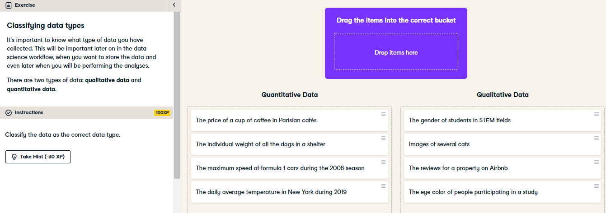

Congratulations! All the data you will work with will be either qualitative or quantitative. It's important to know the difference.

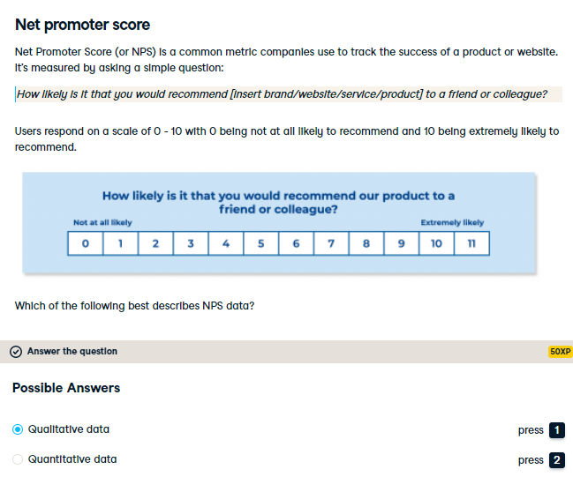

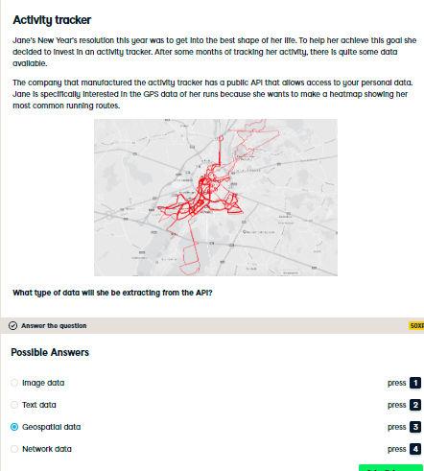

Correct! This is a great example of data with a geographic aspect to it. Jane's running routes are saved as GPS coordinates and can be graphically represented on a map.